**555 Timer Based Boost Converter:**

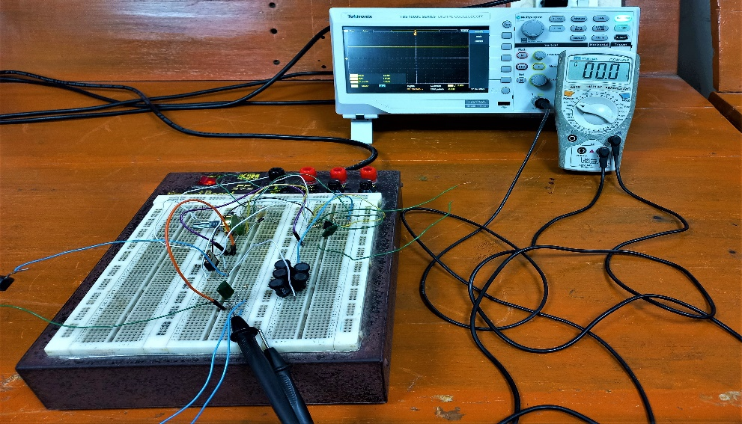

**Fig. 5.2:** Apparatus setup for the experiment of 555 timer based Boost Converter

**Output:**

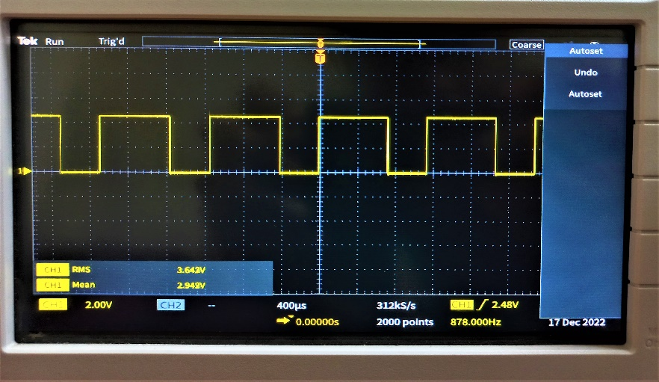

**Fig. 5.3:** Output pulse of 555 timer

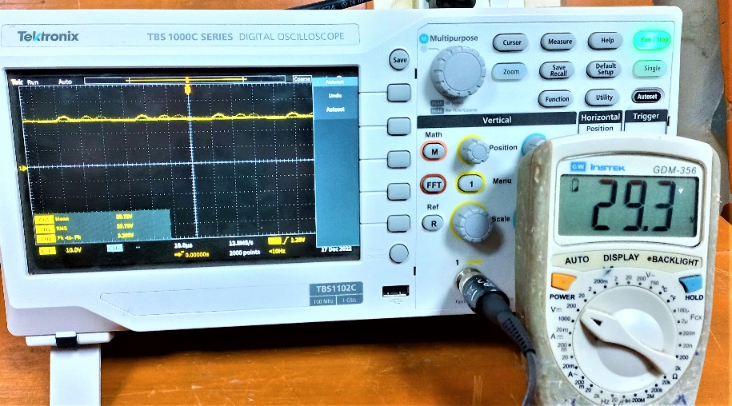

**Fig. 5.4:** Output Waveform for 10K resistence as load

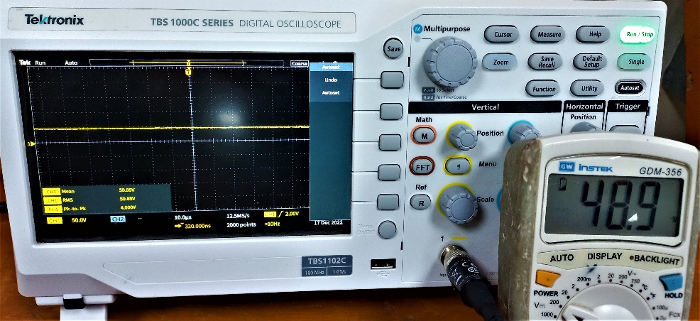

**Fig. 5.5:** Output Waveform for 47K resistence as load

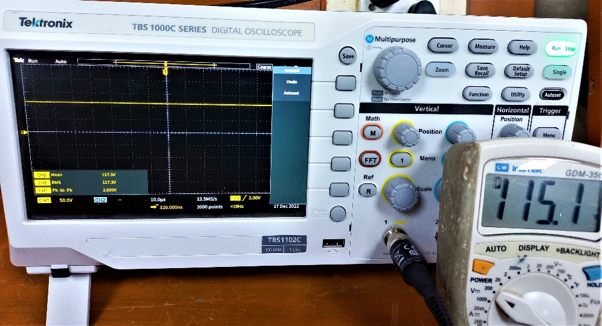

**Fig. 5.6:** Output Waveform for 100K resistence as load

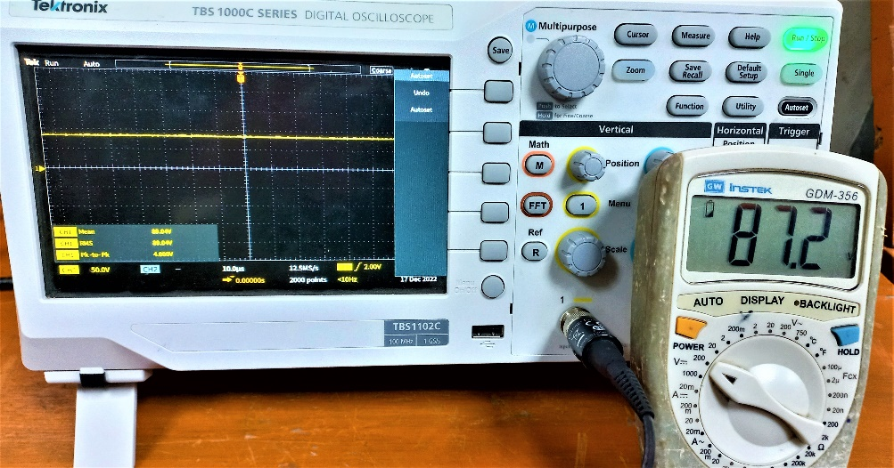

**Fig. 5.7:** Output Waveform for 220K resistence as load